Project Design Phase Solution Architecture

Date | 21 Jan 2026
Team ID | LTVIP2026TMIDS64924
Project Name | Smart sorting
Maximum Marks | 4 Marks

Solution Architecture:
Architecture Overview
- Client (Browser)
  - HTML/CSS/JS pages (index, predict, result, etc.)
  - User selects “Predict,” uploads an image.
- Web Server (Flask App)
  - app.py routes:
    - / → serves index.html
    - /predict → accepts upload, saves image
  - Preprocessing: rescale & resize to 224×224
  - Inference: loads fruit_classifier_model_v5.h5, runs model.predict()
- Model (VGG16 + Top Layers)
  - Pre-trained backbone (blocks 1–5) + custom dense layers
  - Outputs 29-class softmax probabilities
- Response & Presentation
  - Flask returns result.html with predicted label
  - Client displays result box (green/yellow)

Example - Solution Architecture Diagram:

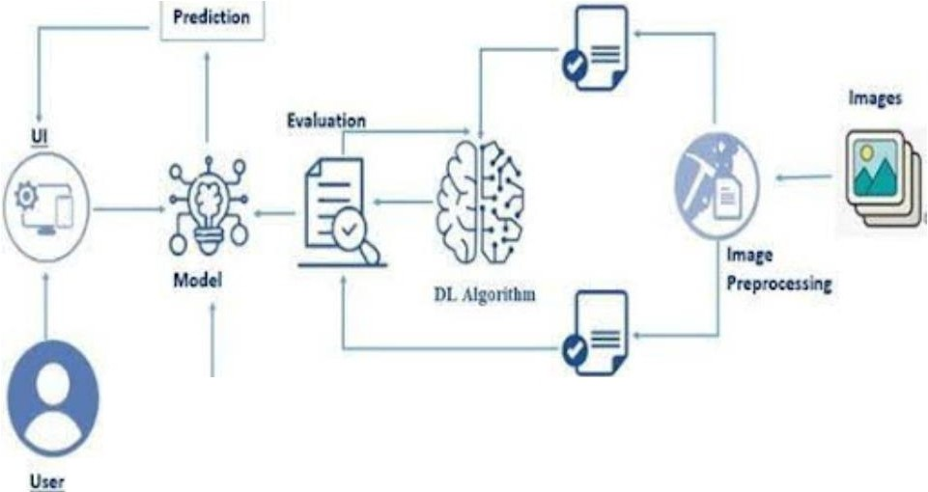
Inputs
Tut 0,1b
Tran Oita

